***Stack in Java Collection***

Java Collection framework provides a Stack class which models and implements the Stack data structure. The class is based on the basic principle of last-in-first-out. In addition to the basic push and pop operations, the class provides three more functions of empty, search and peek. The class can also be said to extend Vector and treats the class as a stack with the five mentioned functions. The class can also be referred to as the subclass of Vector.  
  
This diagram shows the hierarchy of Stack class:  
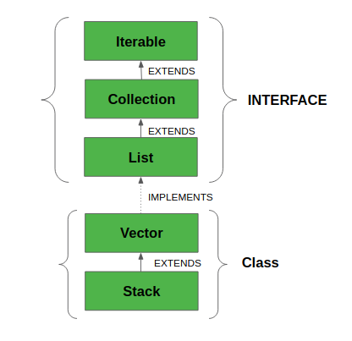  
The class supports one *default constructor* **Stack()** which is used to *create an empty stack*.  
  
Below program shows a few basic operations provided by the Stack class:

Java

// Java code for stack implementation

import java.io.\*;

import java.util.\*;

class Test

{

// Pushing element on the top of the stack

static void stack\_push(Stack<Integer> stack)

{

for(int i = 0; i < 5; i++)

{

stack.push(i);

}

}

// Popping element from the top of the stack

static void stack\_pop(Stack<Integer> stack)

{

System.out.println("Pop :");

for(int i = 0; i < 5; i++)

{

Integer y = (Integer) stack.pop();

System.out.println(y);

}

}

// Displaying element on the top of the stack

static void stack\_peek(Stack<Integer> stack)

{

Integer element = (Integer) stack.peek();

System.out.println("Element on stack top : " + element);

}

// Searching element in the stack

static void stack\_search(Stack<Integer> stack, int element)

{

Integer pos = (Integer) stack.search(element);

if(pos == -1)

System.out.println("Element not found");

else

System.out.println("Element is found at position " + pos);

}

public static void main (String[] args)

{

Stack<Integer> stack = new Stack<Integer>();

stack\_push(stack);

stack\_pop(stack);

stack\_push(stack);

stack\_peek(stack);

stack\_search(stack, 2);

stack\_search(stack, 6);

}

}

**Output**

Pop :

4

3

2

1

0

Element on stack top : 4

Element is found at position 3

Element not found

**Methods in Stack class**:

1. **Object push(*Object element*)** : Pushes an element on the top of the stack.
2. **Object pop()** : Removes and returns the top element of the stack. An 'EmptyStackException' exception is thrown if we call pop() when the invoking stack is empty.
3. **Object peek()**: Returns the element on the top of the stack, but does not remove it.
4. **boolean empty()** : It returns true if nothing is on the top of the stack. Else, returns false.
5. **int search(Object element)** : It determines whether an object exists in the stack. If the element is found, it returns the position of the element from the top of the stack. Else, it returns -1.

**Note:** Please note that the Stack class in Java is a legacy class and inherits from Vector in Java. It is a thread-safe class and hence involves overhead when we do not need thread safety. It is recommended to use [ArrayDeque](https://www.geeksforgeeks.org/arraydeque-in-java/" \t "_blank)for stack implementation as it is more efficient in a single-threaded environment.